Scenario 2: AWS Organizations – Creating an OU and Applying SCP for EC2 Read-Only Access
Create a new Organizational Unit (OU) named Dev-Team, attach a Service Control Policy (SCP) that allows only EC2 read-only actions, and then move the Dev account into that OU.
This setup ensures centralized governance and consistent restriction across all IAM users and roles inside the Dev account.
Request is to create an organization unit under AWS Organization for each department so it will be easy to analyze and map the access.
Step 1: Go to AWS Organizations
Step 2: select the root account, scroll down and select action
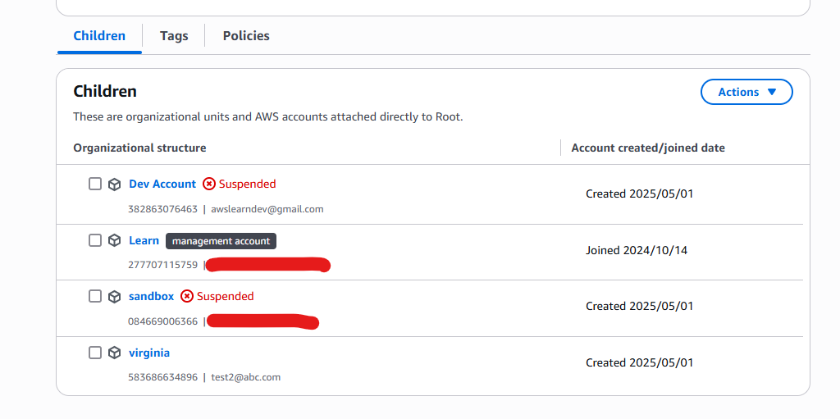
Note: here some account shows, I have created for an testing purpose and closed it. Hence its shows as a suspended.
To Remove an account from an aws organization, the member account must be able to operate independently, means
- It must have a verified root email id.
- It must have a payment method (credit card)
- It must have contact information set up.
Since I don’t have that it will automatically remove by AWS after few days.
Suspended accounts appear because AWS automatically closes them when prerequisites like root email verification, payment method, or contact information are missing. This is expected.

Here dev account, which is primarily used for dev activities, they shouldn’t have IAM console access and ec2 instance they should only have read.
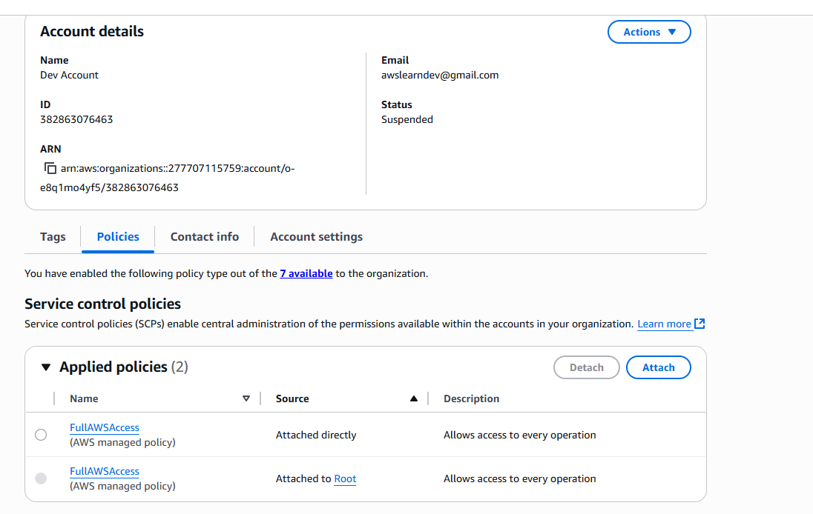
Step 3: lets create an OU for Dev Team and then add dev account in that OU.
Step 4: go to root OU > actions > create new and provide a name Dev-Team
And click on create organizational unit
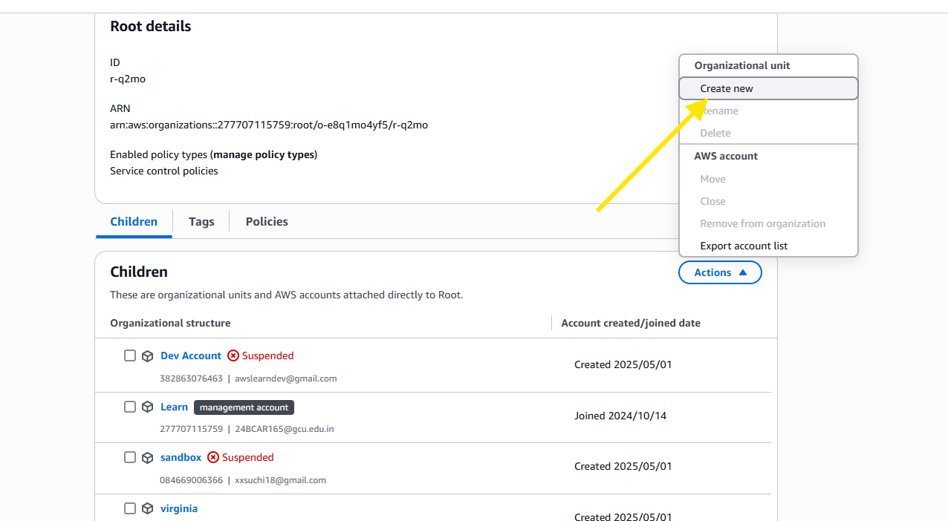
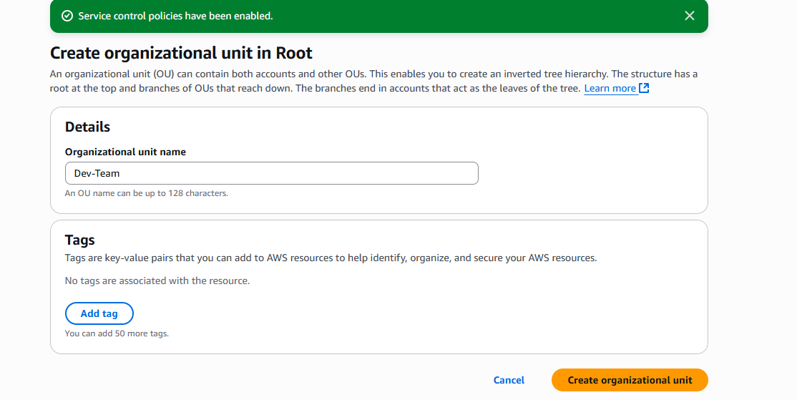
Step 5: Create a Service Control Policy (SCP)
under Aws organization on left side select policies
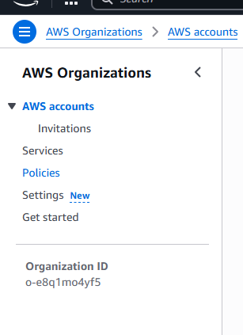
Step 6: Select service control policy (its like border level security policy)
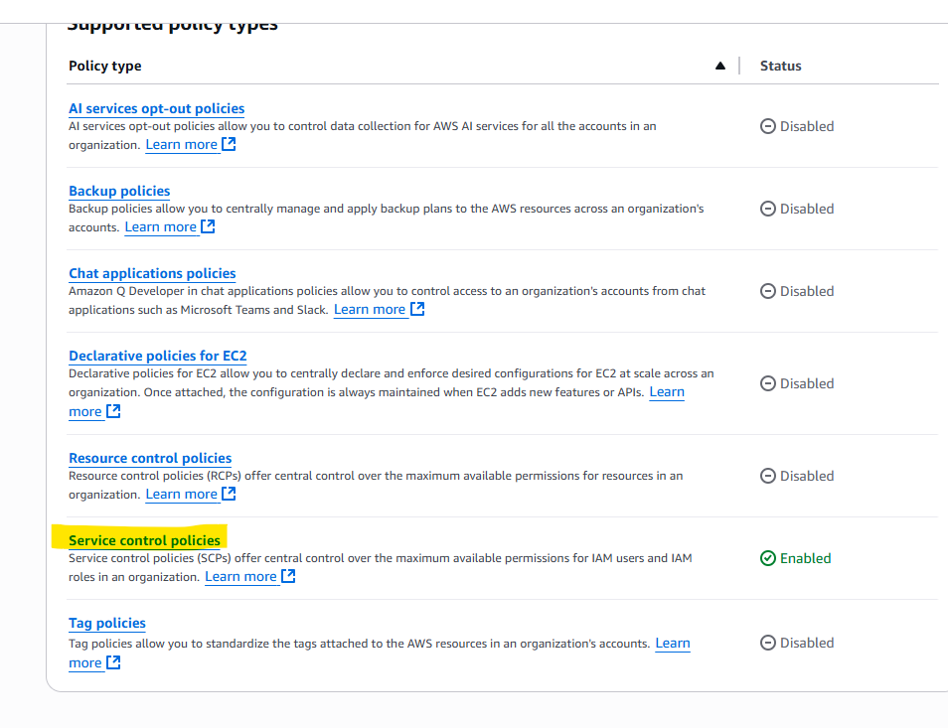
Step 7: click create new policy >enter the policy name and draft the service control policy.
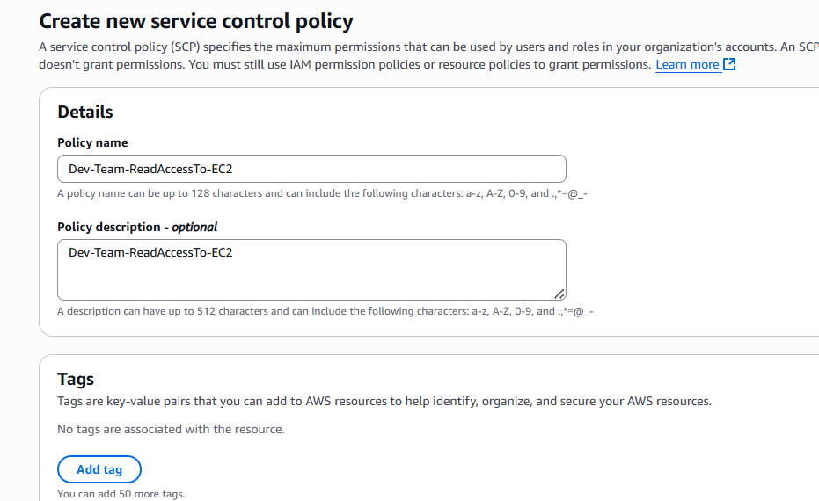
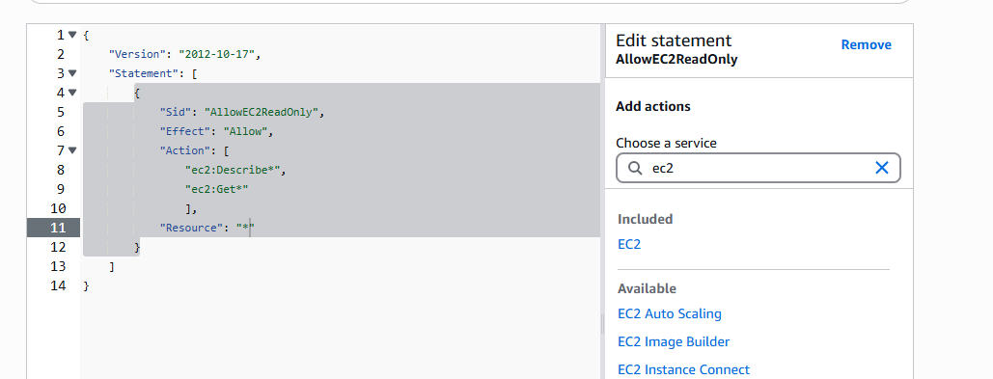
This SCP ensures users in the Dev account can only perform Describe actions (read-only) for EC2.
Step 8: Attach the SCP to the Dev-Team OU
once policy is created click on Dev-Team OU and scroll down and select policies and click on attach
And select the policy which we have prepared
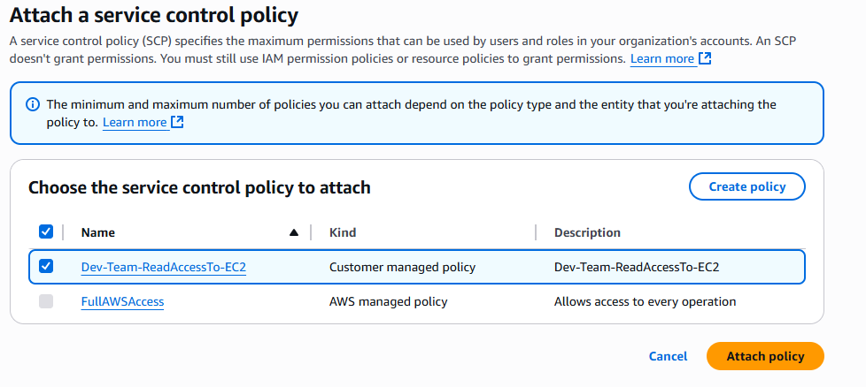
Step 9: since we have attached the policy to the OU. Lets move the dev account to the dev-team ou.
- In AWS Organizations, locate the Dev account
- Select Actions → Move
- Choose the Dev-Team OU
The Dev account is now controlled by the EC2 read-only SCP.

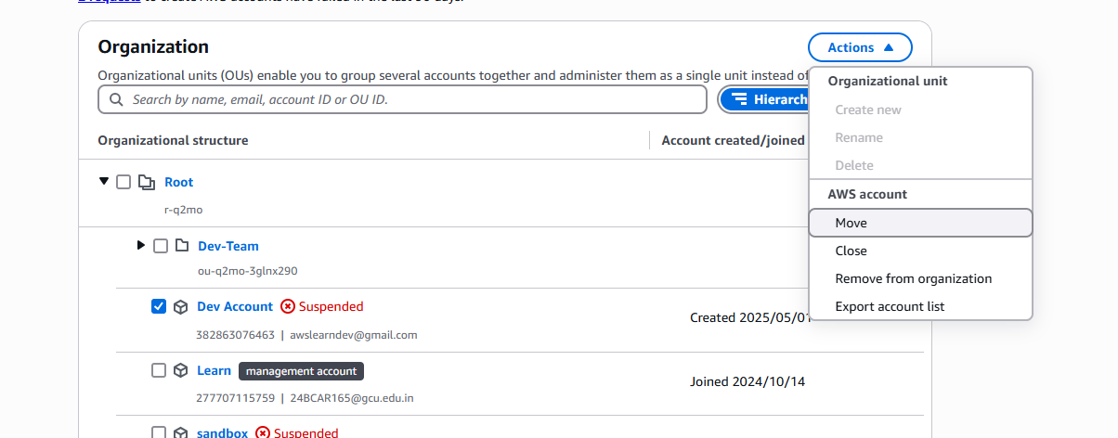
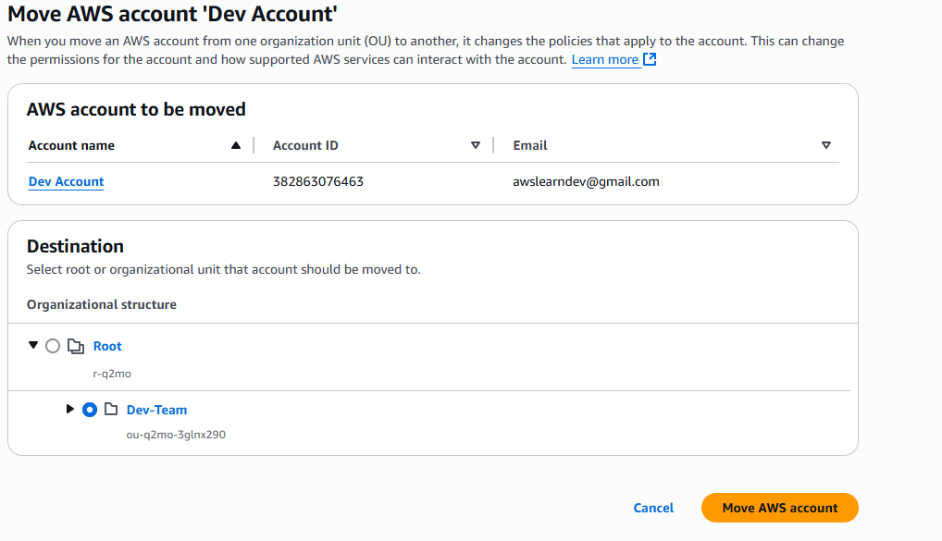
OUR Scenario
We have created an OU: Dev-Team
We have moved dev-account into that OU.
We have attached a custom SCP to the OU that only allows ec2:Describe* actions (i.e., read-only).
Impact
Even if someone in dev-account creates a full-access EC2 policy and attaches it to a user — it won’t work beyond the SCP boundary.
The SCP acts like a global "deny all except…" filter.

